1. CSRF vulnerability with no defenses 2

2. CSRF where token validation depends on request method 3

3. CSRF where token validation depends on token being present 4

4. CSRF where token is not tied to user session 6

5. CSRF where token is tied to non-session cookie 7

6. CSRF where token is duplicated in cookie 9

7. SameSite Lax bypass via method override 10

8. SameSite Strict bypass via client-side redirect 12

9. SameSite Strict bypass via sibling domain 15

10. SameSite Lax bypass via cookie refresh 20

11. CSRF where Referer validation depends on header being present 22

12. CSRF with broken Referer validation 23

# CSRF vulnerability with no defenses

# CSRF where token validation depends on request method

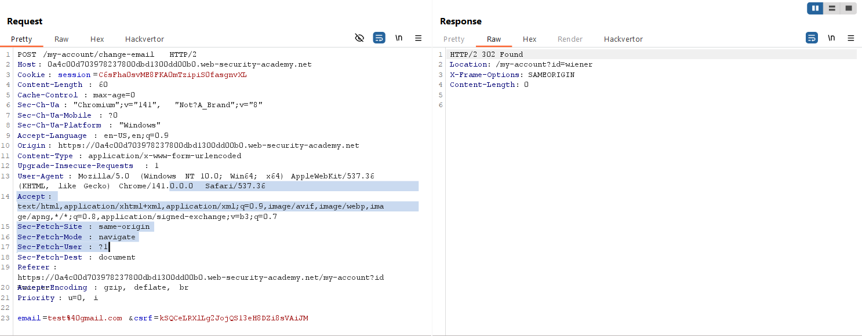

# CSRF where token validation depends on token being present

# CSRF where token is not tied to user session

Trên tài khoản của wiener:peter, capture request update email để lấy csrf token.

Trên tài khoản carlos:montoya, capture request update mail và thay csrf token ở trên và xác nhận rằng token vẫn hoạt động.

Giờ thì tạo dùng 1 csrf token mới để đưa vào trong POC generate CSRF rồi deliver đến victim để solve lab.

# CSRF where token is tied to non-session cookie

# CSRF where token is duplicated in cookie

# SameSite Lax bypass via method override



# SameSite Strict bypass via client-side redirect

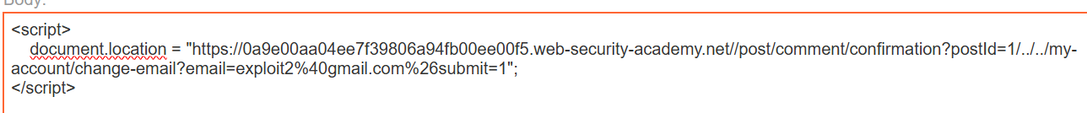

# SameSite Strict bypass via sibling domain

Confirm the CSWSH vulnerability:

Store => view exploit => check in collaborator

Notice that your session cookie was not sent with the request.

In the response, notice that the website explicitly specifies SameSite=Strict when setting session cookies. This prevents the browser from including these cookies in cross-site requests.

Copy url with the GET request then paste in address bar:

# SameSite Lax bypass via cookie refresh

/social-login

From the proxy history, notice that every time you complete the OAuth flow, the target site sets a new session cookie even if you were already logged in.

Note that we've opened the /social-login in a new window to avoid navigating away from the exploit before the change email request is sent.



When prompted, click the page. This triggers the OAuth flow and issues you a new session cookie. After 5 seconds, notice that the CSRF attack is sent and the POST /my-account/change-email request includes your new session cookie.

# CSRF where Referer validation depends on header being present

# CSRF with broken Referer validation

Dùng hàm history.pushState()

